

Faculty of Engineering and Technology
Electrical and Computer Engineering Department
DATA BASE SYSTEMS
COMP333
PHASE 2

I-Tech Electronics Store Management System

Prepared by:
Anis DarHammouda #1230834
Aseel Hamed # 1231891

Supervised by:
Dr. Bassem Sayrafi

Section: 2.

Date: 2026/4/23

Table of Contents
Table of Contents 1
Project Scope and Description 2
1. System Overview 2
2. Core System Functions 2
3. Storage and Organization 2
4. Warranty Management 2
5. Technology and Objectives 2
System Requirements 2
1. Functional Requirements 2
2. Non-Functional Requirements 3
Information about the Client 3
1. Client Overview 3
2. Contact Information 3
3. Client Needs 3
Entities: 4
Relationships: 8
Database Design Analysis: 9
1.Total Participation 9
2. Recursive Relationship 10
3.Non-Binary Relationships 10
4.Class Hierarchy 10
ER Diagram 11
ER Diagram Explanation 12
Sample Queries 13

Project Scope and Description

1. System Overview
This project is about developing a database application for I-Tech, which is a local electronics store. The store sells different types of products such as smartphones, laptops, and accessories. The main goal of the system is to help organize and manage the daily operations of the store in a clear and efficient way.

2. Core System Functions
The system mainly focuses on organizing product information such as product details, categories, and brands. In addition, it helps track suppliers and customers, while also supporting both sales and purchase transactions.

3. Storage and Organization
The store contains different storage areas, such as a showroom at the front and a storage room, along with other spaces. These areas are divided into multiple storage sections. Each section represents a physical place where products are stored and organized to make access easier.

4. Warranty Management
The system also supports product warranties. Some products, especially devices like smartphones and laptops, may have a warranty, while others, such as some accessories, may not. Warranty information is stored separately and linked only to the products that have a warranty.

5. Technology and Objectives
The system will be developed using Java for the application and MySQL for the database. The main objective is to reduce errors, organize data properly, and make the store’s daily work easier and more efficient..

System Requirements

1. Functional Requirements
The system is expected to support a set of main features like:
- Add, update, delete, and view products
- Manage product categories, suppliers, and customers
- Record purchase and sales transactions
- Track inventory quantities
- Generate reports related to stock, sales, and purchases

2. Non-Functional Requirements
The system should meet the following requirements: easy to use, accurate and reliable, connect properly to MySQL, also should support a graphical user interface using JavaFX, and handle daily store operations efficiently

Information about the Client

1. Client Overview
The client is a local electronics store called I-Tech, located in one of the towns in Ramallah. The store sells a variety of electronic products such as smartphones, laptops, chargers, headphones, keyboards, mice, and other accessories.

2. Contact Information
The store can be contacted through the following:
- Phone: (+970-567200596)
- Email: itech@gmail.com

3. Client Needs
The client needs a system that helps organize product data, manage supplier and customer information, track stock levels, and record both sales and purchase transactions. The system should also provide useful reports that help in managing the business more effectively.

NOTE: The entities, attributes, and relationships included in this phase represent an initial design of the system. These elements are not final and may be modified or improved later based on the project requirements and implementation needs.

Entities:

The system is designed based on several entities that represent the main components of the electronics store. These entities were identified according to the system requirements and the operations performed within the store.
Product Entity:
Attribute | Description
Product_ID (PK) | Unique identifier for each product
Category_ID (FK) | Refers to the category of the product
Brand_ID (FK) | Refers to the brand of the product
Product_Name | Name of the product
Model | Product model
Price | Selling price
This entity represents all products available in the store.
Category Entity:
Attribute | Description
Category_ID (PK) | Unique identifier
Category_Name | Name of the category
Used to classify products.
Supplier Entity:
Attribute | Description
Supplier_ID (PK) | Unique identifier for the supplier
Supplier_Name | Name of the supplier
Company_Name | Company name that the supplier work with
Phone | Phone for contact
Address | Address of the supplier
Stores supplier info.
Customer Entity:
Attribute | Description
Customer_ID (PK) | Unique identifier for customers
Customer_Name | Name of the customer
Phone | Phone for contact
Stores customer info.

Storage_Section Entity:
Attribute | Description
Section_ID (PK) | Unique identifier for the section
Section_Name | Name of storage section
Section_Type | Type (like showroom or Backroom)
Represents the different storage areas in the store, such as the showroom, backroom, and other sections where products are stored and organized.
Purchase Entity:
Attribute | Description
Purchase_ID (PK) | Unique identifier for purchase transaction
Supplier_ID (FK) | Foreign key from supplier entity
Purchase_Date | Date of purchase transaction
Delivery_Date | The delivery date of it
Total_Amount | Total cost of the purchase transaction
Represents purchase transactions and the suppliers they are made from.
Sale Entity:
Attribute | Description
Sale_ID (PK) | Unique identifier for sale transaction
Customer_ID (FK) | Foreign key from Customer entity
Sale_Date | Date
Total_Amount | Total
Represents sale transaction and the customer which are made for.
Employee Entity:
Attribute | Description
Employee_ID (PK) | Unique identifier for the Employee
Employee_Name | Name of Employee
Position | Working position of Employee
Salary | Employee salary
Phone | Phone number of Employee
Stores employees working in the store.
Brand Entity:
Attribute | Description
Brand_ID (PK) | Unique identifier for Brand
Brand_Name | Name of the Brand
Website | The website of the Brand
Represents product brands, such as Apple, Samsung, and other manufacturers.
Sale_Details Entity:
Attribute | Description
Sale_ID (FK) | Foreign key from Sale entity
Product_ID (FK) | Foreign key from Product entity
Quantity | Quantity of product in the sale transaction
Unit_Price | The price of unit
Represents the items included in each sale, including the product, quantity, and unit price.
Purchase_Details Entity:
Attribute | Description
Purchase_ID (FK) | Foreign key from Purchase entity
Product_ID (FK) | Foreign key from Product entity
Quantity | Quantity of product in the Purchase transaction
Unit_Price | The price of unit
Represents the products included in each purchase, along with their quantities and unit prices. Each record corresponds to a specific product within a specific purchase.
Warranty (Weak Entity):
Attribute | Description
Product_ID | The Primary key from owner entity (Product)
Warranty_Number | Partial key for the warranty
Warranty_Type | Type of warranty
Warranty_Period | Period time of warranty
Start_Date | Start date of warranty
Represents warranty information for products that include a warranty, such as its type and duration. Each warranty is associated with a specific product and cannot exist independently (because it is weak entity).
Storage_Details Entity:
Attribute | Description
Product_ID (FK) | Foreign key from Product entity
Section_ID (FK) | Foreign key from Storage_section entity
Quantity | Quantity of product stored
Represents the current stock quantity of the product.
Supplier_Product Entity:
Attribute | Description
Supplier_ID (FK) | Foreign key from Supplier entity
Product_ID (FK) | Foreign key from Product entity
Supply_Price | Price of product
Represents the products supplied by each supplier along with their supply prices.

Payment Entity:
Attribute | Description
Payment_ID (PK) | Unique identifier of payment transaction
Sale_ID (FK) | Foreign key from Sale entity
Payment_Date | Date of payment
Amount | Payment amount
Payment_Method | Method of payment (like cash or installment)
Payment_Status | Payment status (paid or pending)
Represents payments made by customers for sales transactions, including details such as payment method and status. Each payment is associated with a specific sale.
Return_Record Entity:
Attribute | Description
Return_ID (PK) | Unique identifier for each return record
Sale_ID (FK) | Part of a composite foreign key referencing Sale_Details
Product_ID (FK) | Part of a composite foreign key referencing Sale_Details
Return_Date | Date of return
Quantity | Returned quantity
Return_Reason | Reason for return
Return_Status | Status of the return (like: approved, pending)
Represents products that are returned by customers after a sale, including details such as quantity, reason, and status. Each return is associated with a specific product within a specific sale.
Stock_Movement_History Entity:
Attribute | Description
Movement_ID (PK) | Unique identifier for each stock movement
Section_ID (FK) | Foreign key from storage_section entity
Product_ID (FK) | Foreign key from Product entity
Movement_Type | Type of movement (like: purchase, sale, return, transfer)
Movement_Date | Date of movement
Quantity | Quantity of product moved
Stores records of all stock movements, including the type, date, and quantity. Each entry represents a specific movement of a product.

Relationships:

Entities | Relationship | Description | Type
Category & Product | belongs to | Each category can include many products and each product belongs to only one category | 1:M
Supplier & Supplier_Product | supplies | A supplier can be associated with many supplier-product records and each supplier-product record belongs to one supplier | 1:M
Product & Supplier_Product | is supplied by | A product can be associated with many supplier-product records and each supplier-product record belongs to one product | 1:M
Customer & Sale | makes | A customer can make many sales transactions and each sale is made by one customer | 1:M
Sale & Sale_Details | includes | A sale can include multiple detail records, and each record belongs to one sale. | 1:M
Product & Sale_Details | appears in | A product can appear in multiple sale detail records and each sale detail record refers to one product. | 1:M
Purchase & Purchase_Details | includes | Each purchase can include multiple purchase detail records and each purchase detail record belongs to one purchase. | 1:M
Product &  Purchase_Details | appears in | A product can appear in multiple purchase detail records and each purchase detail record refers to only one product. | 1:M
Supplier & Purchase | provides | A supplier can be associated with many purchase transactions and each purchase is linked to one supplier. | 1:M
Employee & Employee | supervises | An employee can supervise multiple employees, while an employee may or may not have a supervisor (Recursive Relationship) | 1:M
Brand & Product | produces | Each brand can produce many products and each product belongs to one brand. | 1:M
Product & Warranty | has | Each product can have one warranty and each warranty belongs to one product. | 1:1
Storage_Section & Storage_Details | contains | Each storage section can contain multiple storage detail records and each storage detail record belongs to one storage section. | 1:M
Product & Storage_Details | is stored in | A product can appear in multiple storage detail records and each storage detail record refers to one product. | 1:M
Relationships Overview

Entities | Relationship | Description | Type
Sale & Payment | has | Each sale can have one or more payments and each payment belongs to only one sale. | 1:M
Sale_Details & Return_Record | has | Each sale detail record can have zero or more return records and each return record belongs to one sale detail record. | 1:M
Product & Stock_Movement_History | has | A product can have multiple stock movement records and each stock movement record belongs to one product. | 1:M
Storage_Section & Stock_Movement_History | records | A storage section can have multiple stock movement records and each stock movement record belongs to one storage section. | 1:M
Relationships Overview (Continued)

Database Design Analysis:

1.Total Participation
- Product & Warranty
Total participation from Warranty side : All warranties must be associated with a product
- Customer & Sale
Total participation from Sale side: Every sale must be made by a customer
- Supplier & Purchase
Total participation from Purchase side: Every purchase must be linked to a supplier
- Sale & Payment
Total participation from Payment side: Every payment must belong to a sale
- Sale_Details & Return_Record
Total participation from Return_Record side: Every return must be associated with a sale detail record
- Product & Stock_Movement_History
Total participation from Stock_Movement_History side: Every stock movement must be related to a product
- Storage_Section & Stock_Movement_History
Total participation from Stock_Movement_History side: Every stock movement must be associated with a storage section
- Sale & Sale_Details
Total participation from Sale_Details side: Every sale detail record must belong to a sale
- Product & Sale_Details
Total participation from Sale_Details side: Every sale detail record must refer to a product
- Purchase & Purchase_Details
Total participation from Purchase_Details side: Every purchase detail record must belong to a purchase
- Product & Purchase_Details
Total participation from Purchase_Details side: Every purchase detail record must refer to a product
- Supplier & Product_Supplier
Total participation from Product_Supplier side: Every supplier-product record must be associated with a supplier
- Product & Product_Supplier
Total participation from Product_Supplier side: Every supplier-product record must be associated with a product
- Storage_Section & Storage_Details
Total participation from Storage_Details side: Every storage detail record must belong to a storage section
- Product & Storage_Details
Total participation from Storage_Details side: Every storage detail record must refer to a product
- Category & Product
Total participation from Product side: Every product must belong to a category
Note: All other relationships in the diagram have partial participation.

2. Recursive Relationship
The system includes a recursive relationship in: Employee & Employee. Since an employee can supervise multiple employees. So each employee may or may not have a supervisor. The type of the relation is One-to-Many (recursive) with partial participation.

3.Non-Binary Relationships
The current system does not require ternary relationships because all requirements can be represented using binary relationships.

4.Class Hierarchy
Although class hierarchies were considered, the system uses a Category entity to classify products, which provides a simpler and more suitable design for this project.

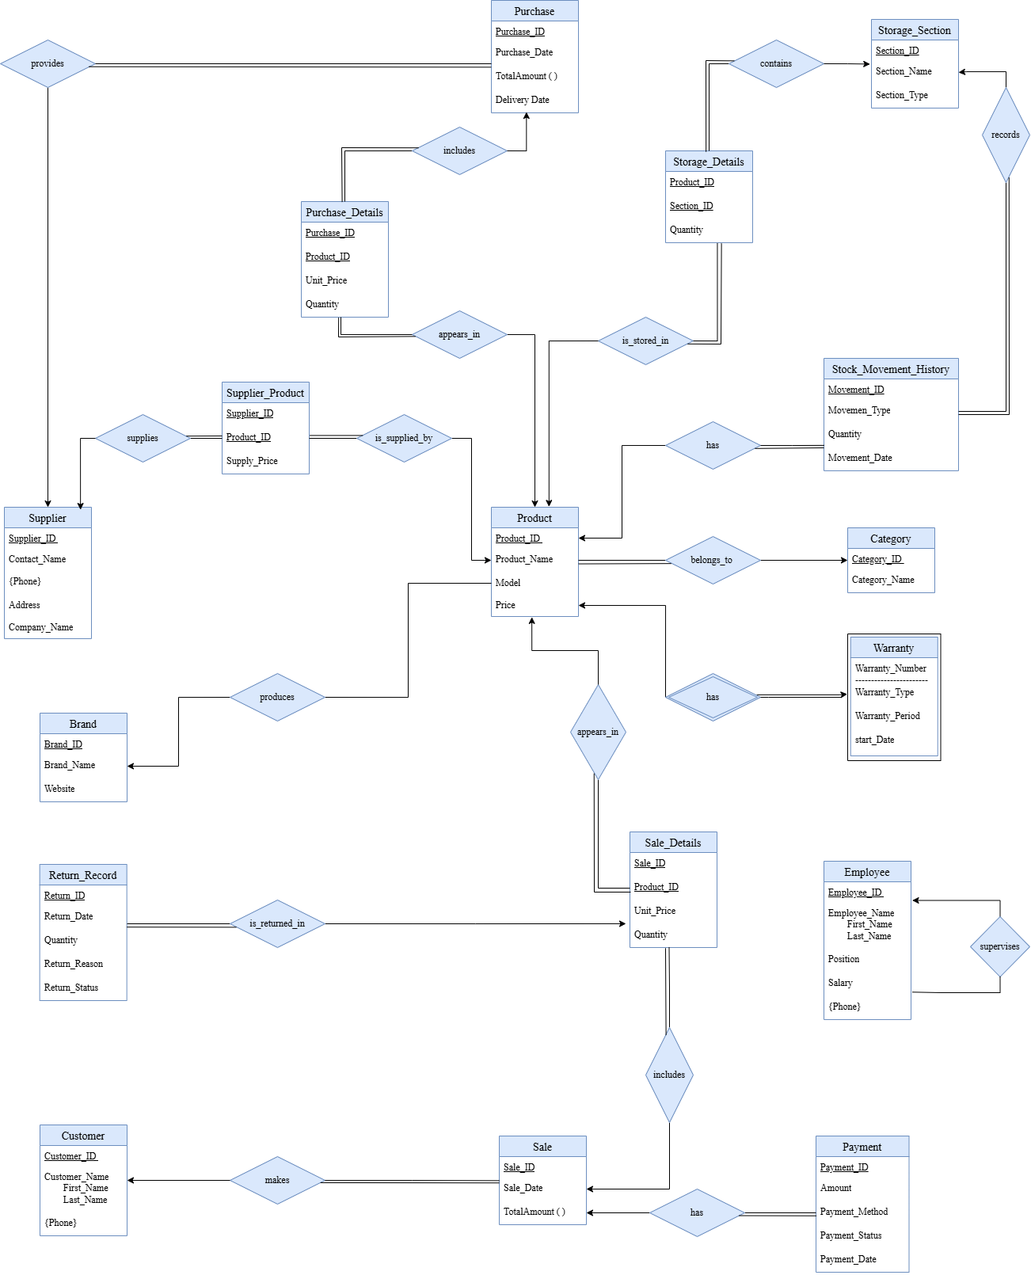
ER Diagram

ER Diagram Explanation

1. General Explanation
The ER diagram shows the general structure of the database for the electronics store. It explains how the main entities like Product, Sale, Purchase, Customer, and Supplier are connected together using different relationships.
Also, it helps to understand how the data moves inside the system, like in sales, purchases, managing stock, and returns. So basically it gives a full picture of how everything is related.

2. Important Design Decisions
While working on the ER diagram, we made some important decisions to make the design clearer and more organized.
First, the many-to-many relationships (like between Sale and Product, Purchase and Product, Supplier and Product, and Storage_Section and Product) were converted into separate tables. These tables are Sale_Details, Purchase_Details, Product_Supplier, and Storage_Details. This was needed because we also had extra attributes like quantity and price.
Another thing we did was linking Return_Record with Sale_Details instead of linking it directly with Sale and Product. This makes more sense because each return actually belongs to a specific product inside a specific sale, not just the sale in general.
Also, Warranty was designed as a weak entity, since it depends on Product and cannot exist alone.
In addition, some attributes were modeled differently based on their nature. For example, phone numbers were considered as multi-valued attributes, since a supplier or customer can have more than one phone number. Also, some values such as total amounts can be derived from other attributes, so they were treated as derived attributes..
Finally, we used total participation in some cases where it is required that an entity must be related to another one. For example, every Sale must have a Customer, and every Payment must be linked to a Sale.

3. Relationships Explanation
The relationships in the diagram show how the entities interact with each other.
For example, a Customer can make more than one Sale, and each Sale can include multiple products using Sale_Details. Products are also connected to Category and Brand.
Also, stock movement is handled using Stock_Movement_History, which is connected to both Product and Storage_Section to track changes in inventory.

Sample Queries

- Retrieve product names, categories, brands, and prices for all products, sorted by category and product name.
- Retrieve product names, brands, prices, and stock quantities of all products supplied by a specific supplier, sorted by product name.
- Retrieve total stock quantity for each category, sorted by total quantity in descending order.
- Retrieve product names, categories, brands, and stock quantities of all products with low stock quantity, sorted by stock quantity.
- Retrieve sale IDs, customer names, sale dates, and total amounts for all sales made on a specific date, sorted by total amount.
- Retrieve product names, categories, brands, and stock quantities of all products stored in a specific storage section, sorted by product name.
- Retrieve product names and total sold quantities of the most sold products, sorted by sold quantity in descending order.
- Retrieve customer names and the total value of their sales transactions.
- Retrieve product names, categories, brands, and prices of products that were never sold, sorted by product name.
- Retrieve the average price of products in each category, sorted by average price in descending order.
- Retrieve total sales amount per day.
- Retrieve purchase ID, purchase date, supplier name, product names, quantities, and total amount for a specific purchase transaction.
- Retrieve product names, categories, models, prices, and stock quantities of all products of a specific brand, sorted by category and price.
- Retrieve the top 5 brands with the highest number of products.
- Retrieve sale IDs, sale dates, and total amounts for all sales made by a specific customer, sorted by sale date.
- Retrieve supplier names and phone numbers of all suppliers, sorted by supplier names.
- Retrieve product names, categories, brands, and prices of all products with price less than a specific value, sorted by price.
- Retrieve employee names, positions, salaries, and phone numbers of all employees supervised by a specific manager, sorted by employee name.
- Retrieve the average salary of all employees.
- Retrieve employee names, positions, and salaries of employees who earn above the average salary, sorted by salary in descending order.
- Retrieve the most expensive product in each category, including product name, category, and price.

